How to Log into Microsoft Teams

On a smartphone, tablet, or iPad:

- Download the Microsoft Teams app.

- Log in with your Surrey username and password and click ‘Sign in.’

- Click on your teacher’s name.

On a computer or laptop:

1. Enter https://sd36.ca/o into your browser. We recommend using Google Chrome.

2. Log in with your Surrey username and password and click ‘Sign in.’

3. Click the ‘Teams’ link to open Teams.

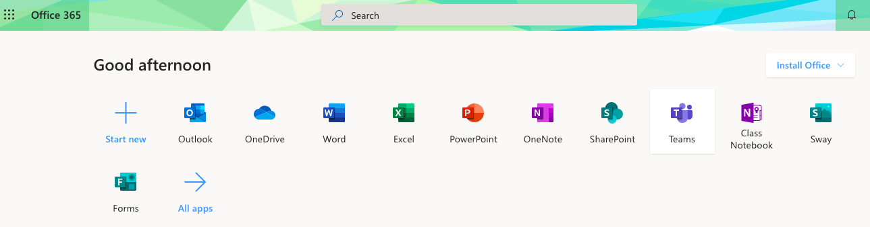

4. Click on your teacher’s name.

